Start: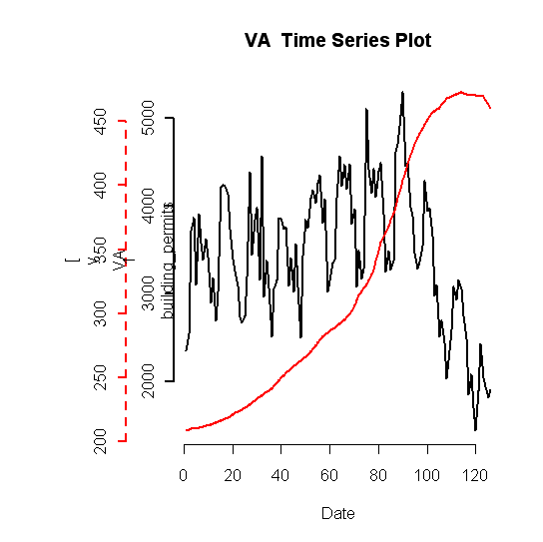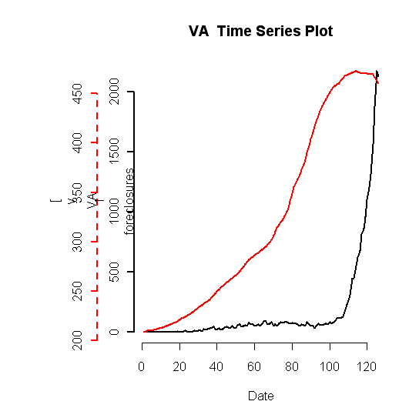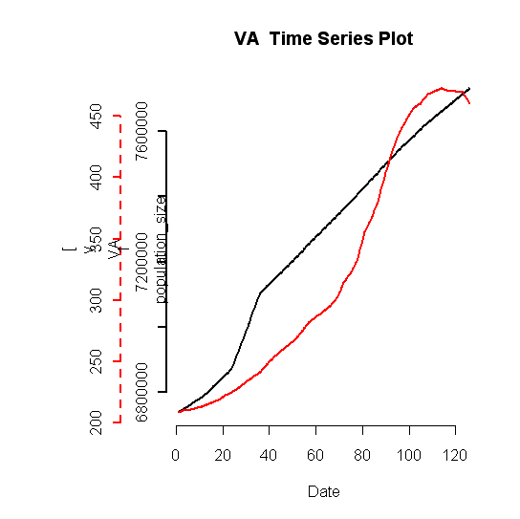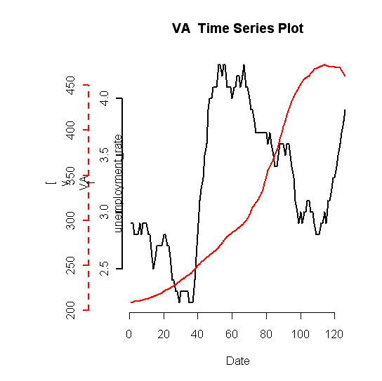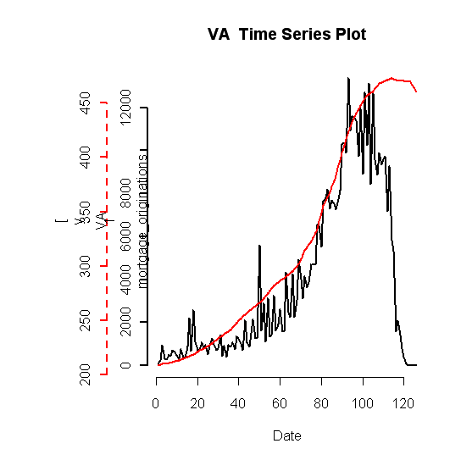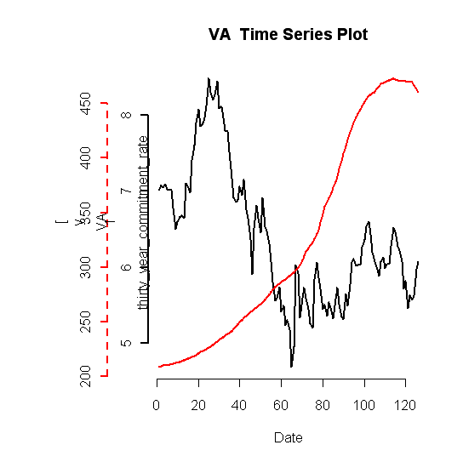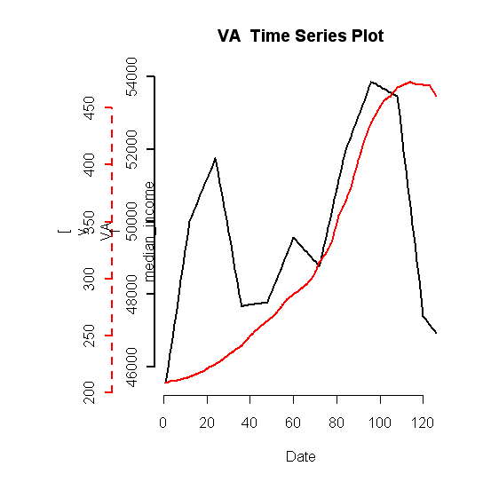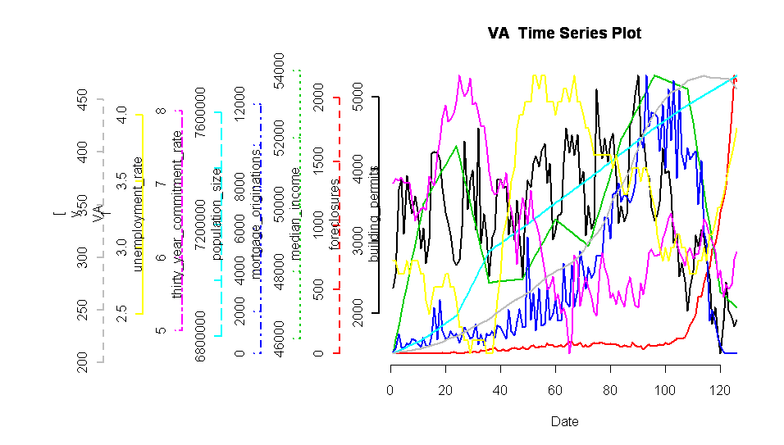

Based on these time series of the data, we picked these lags to test:

median_income | thirty_year_commitment_rate | mortgage_originations | unemployment_rate | population_size | foreclosures | building_permits
18,24 | 0,6 | 12,24 | 0,6 | -3,3 | 0,10 | 18,24

Plots of lagged vars and VA HPI:

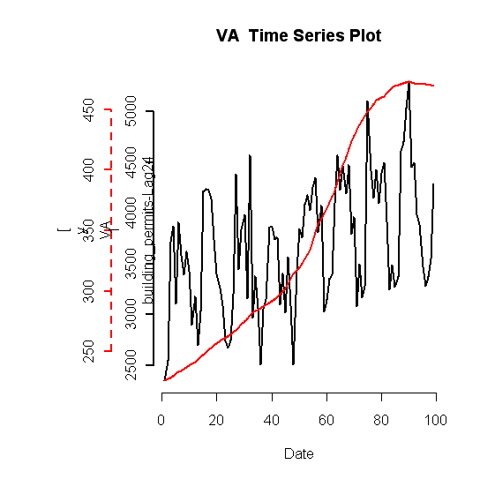
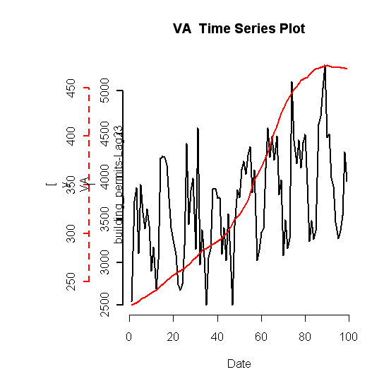
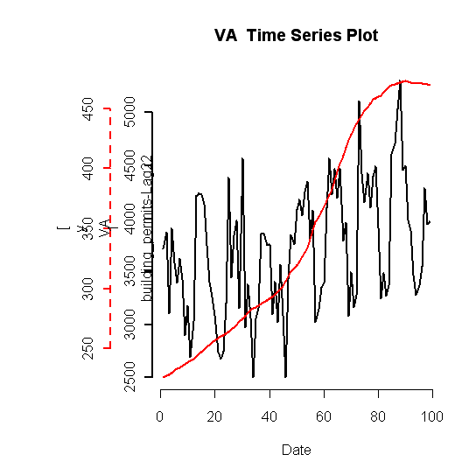
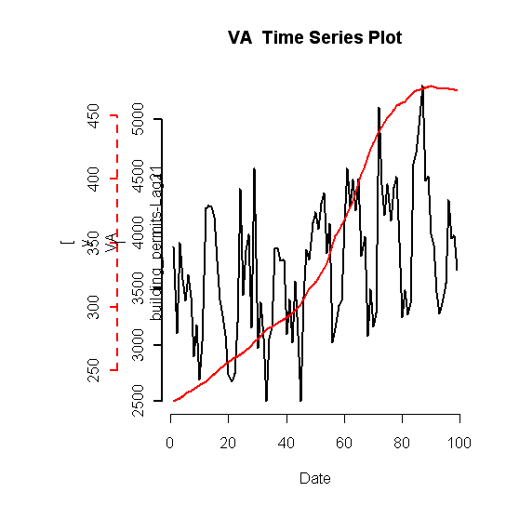
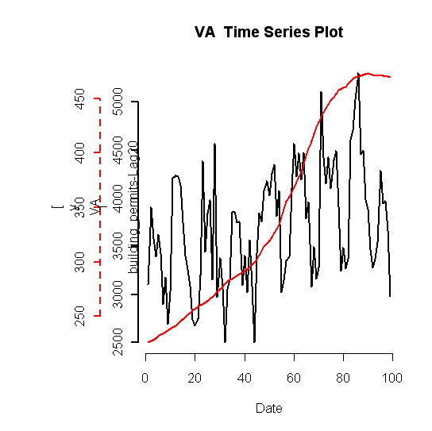
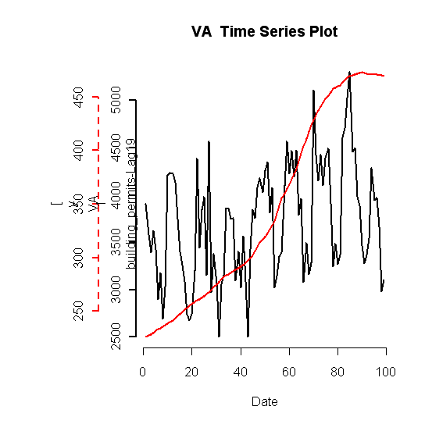
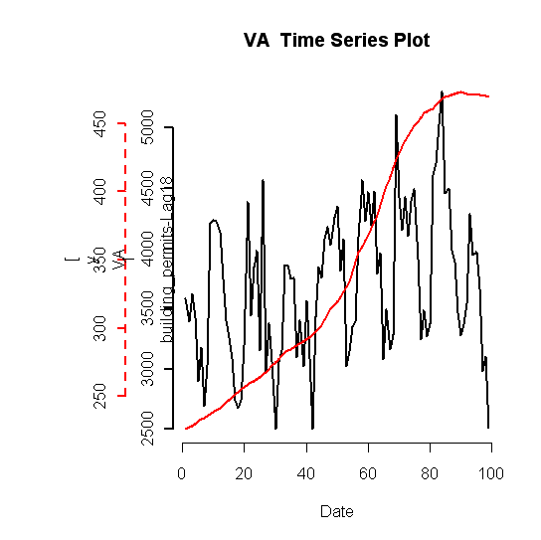
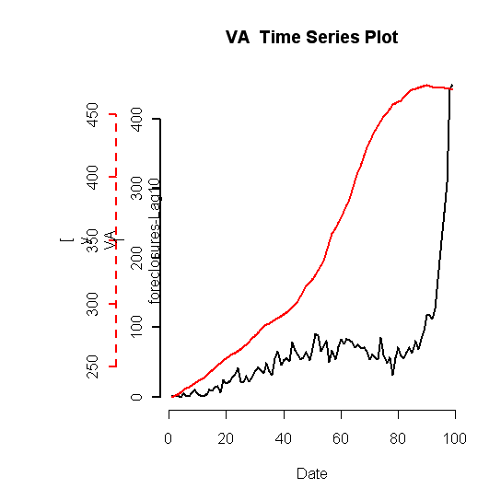
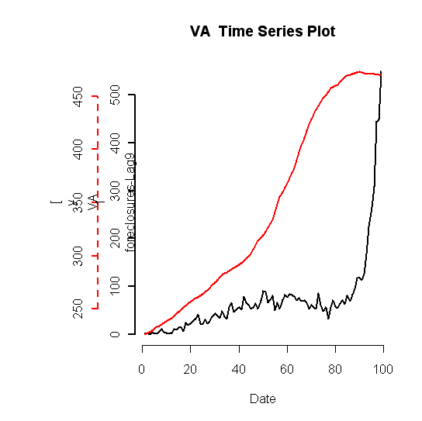
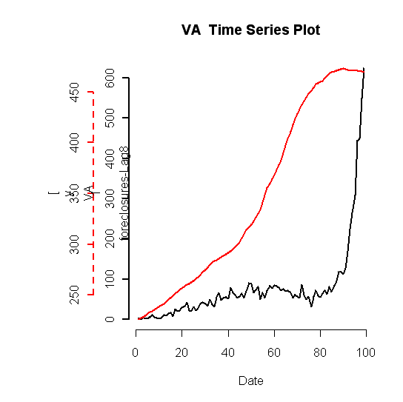
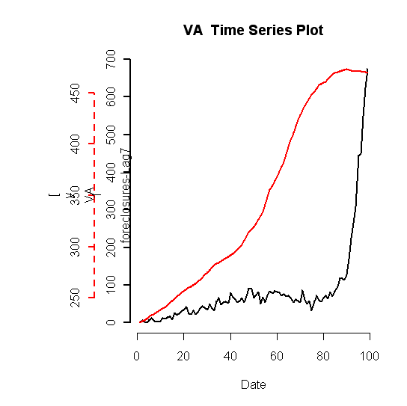
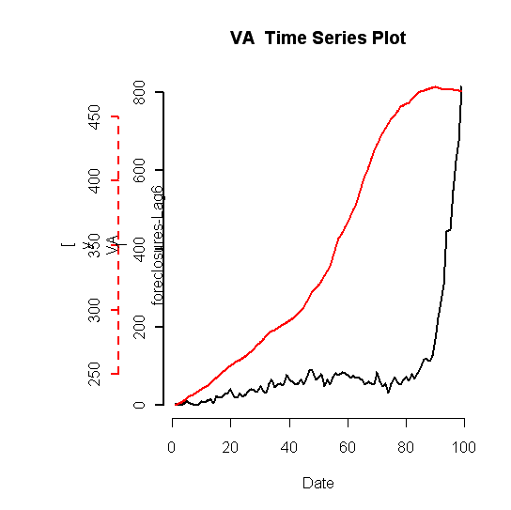
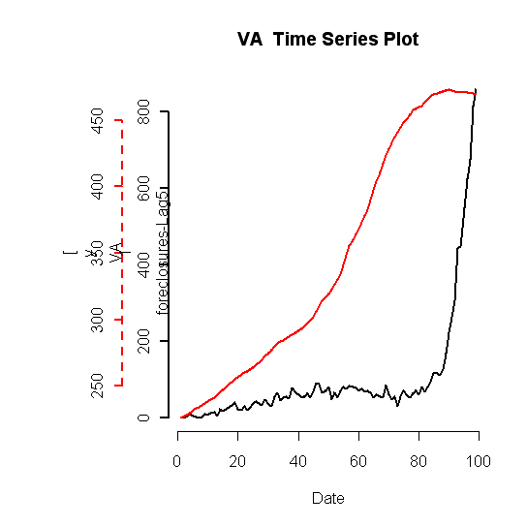
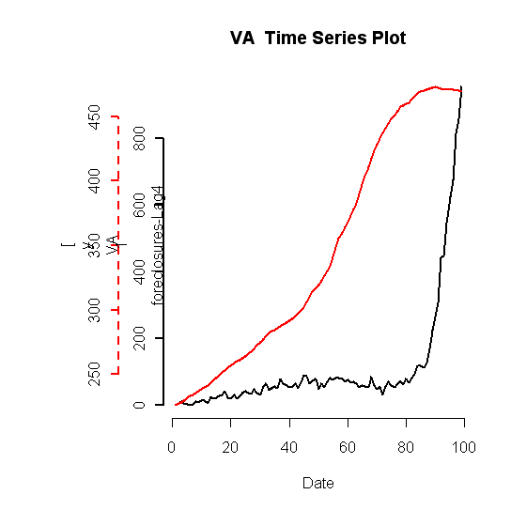
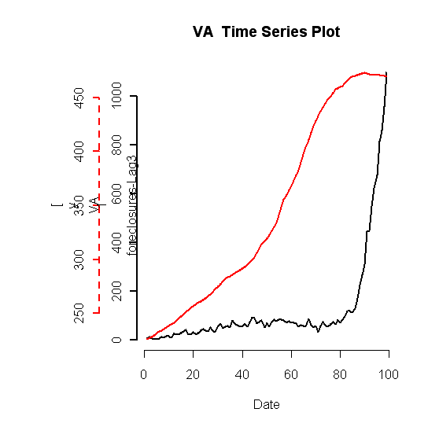
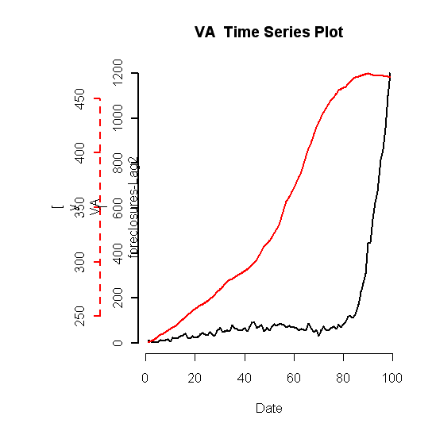
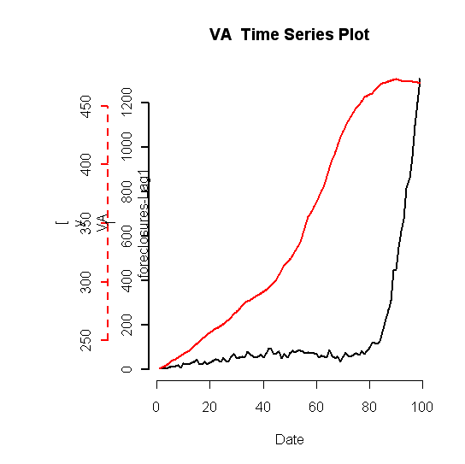
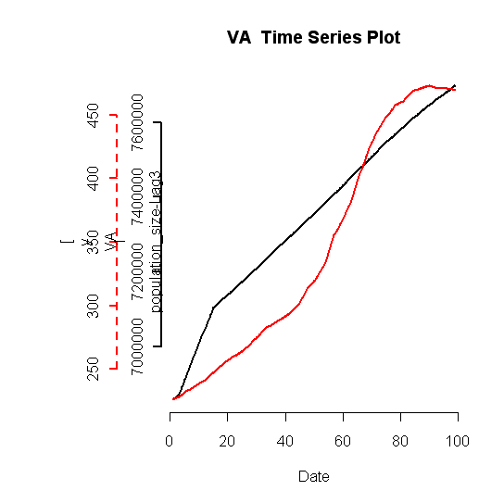
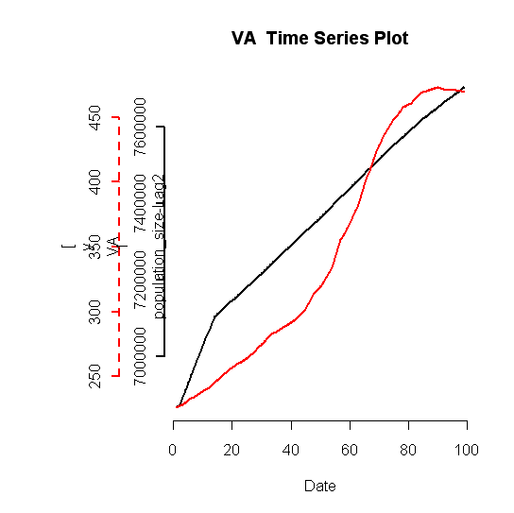
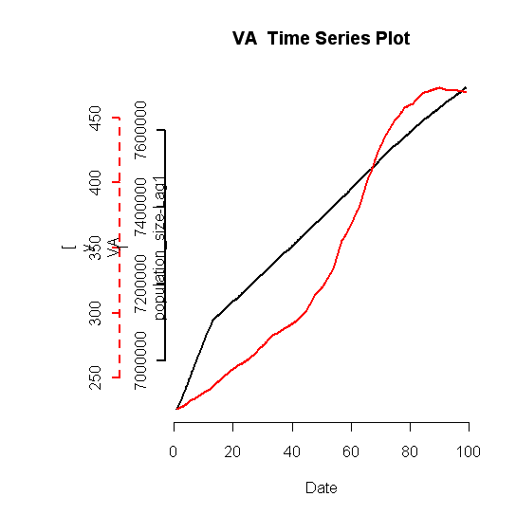
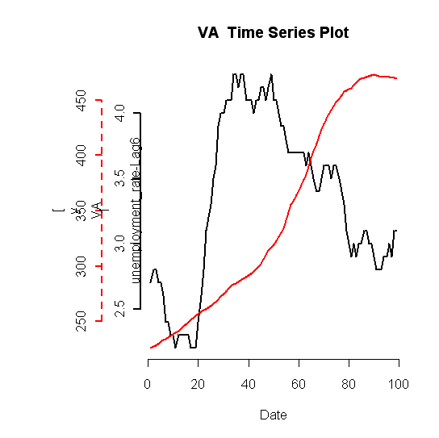
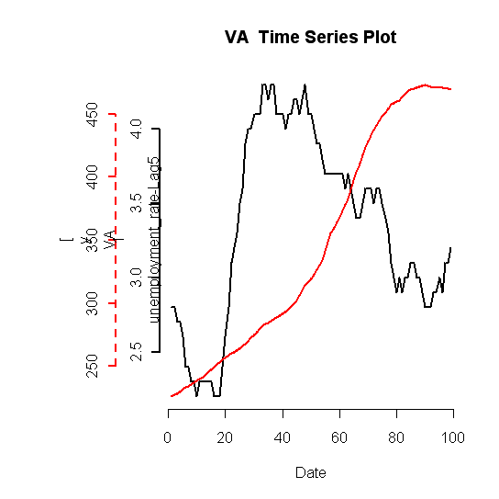
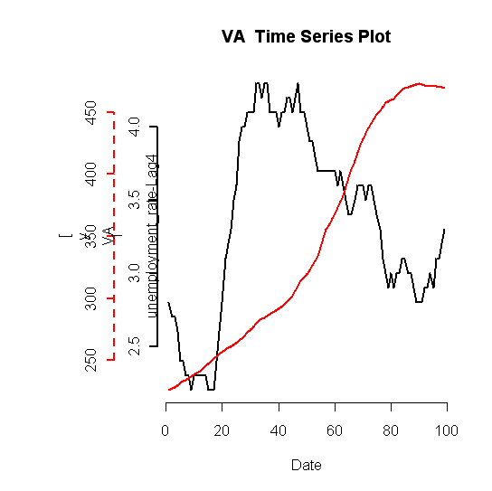
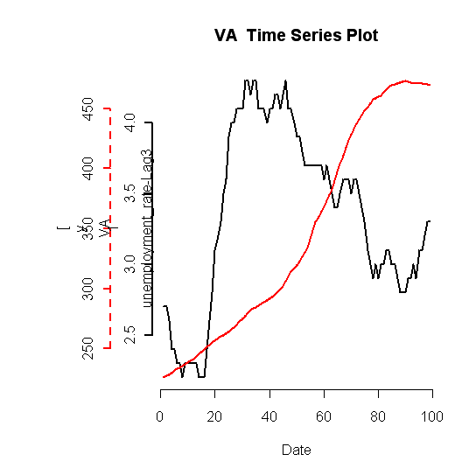
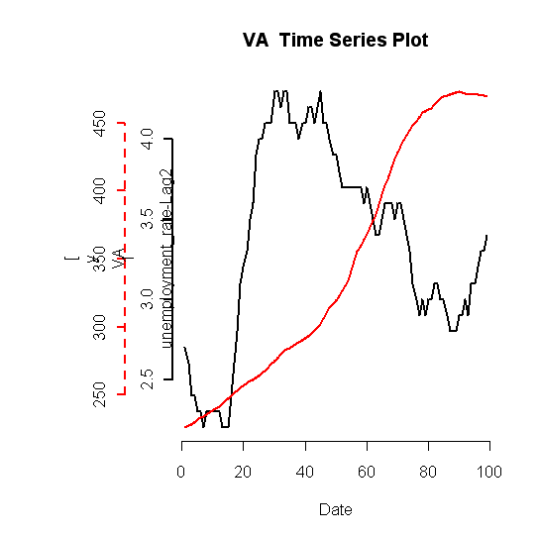
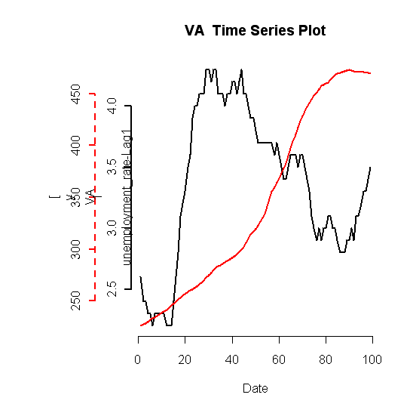
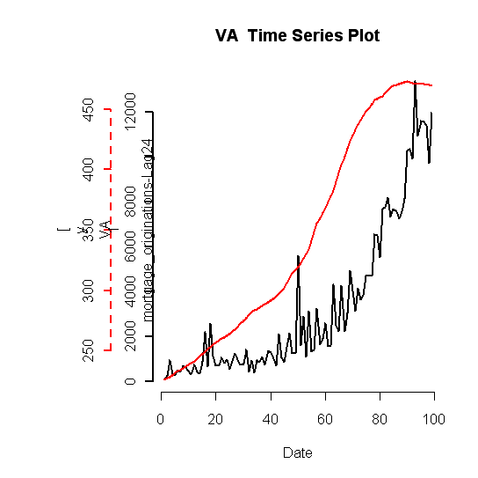
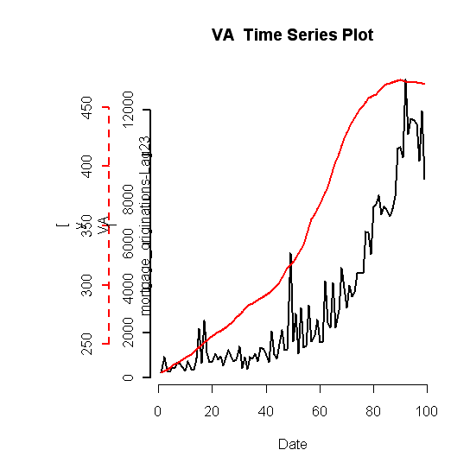
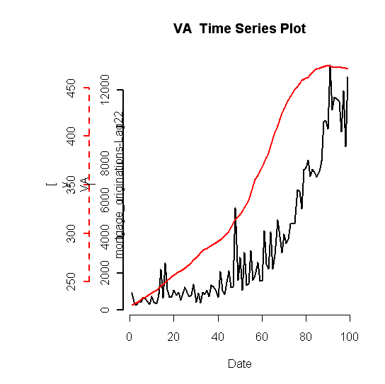
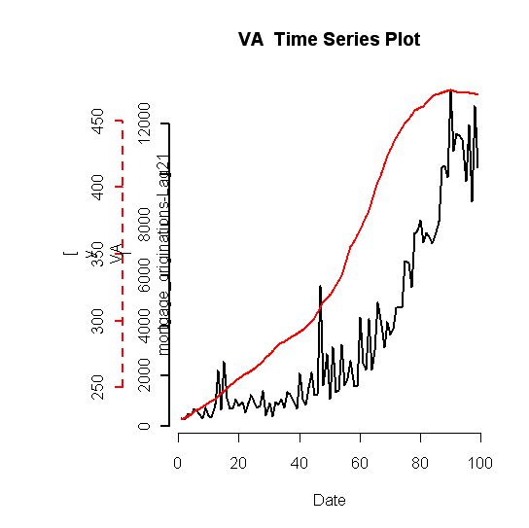
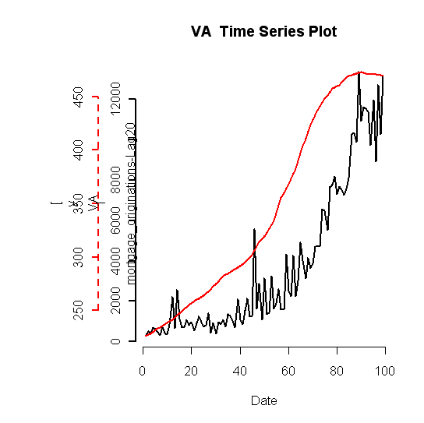

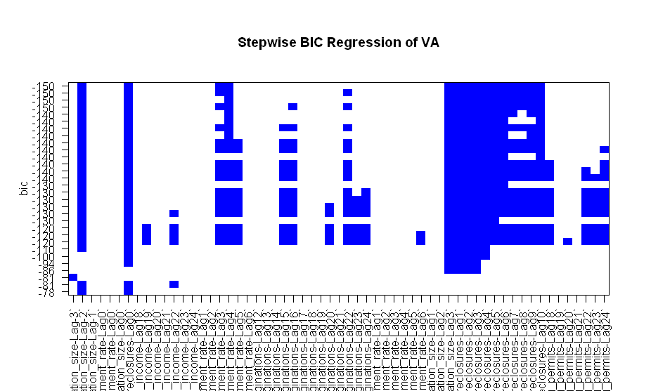

Fit rlm with all lagged vars:
Call: rlm(x = shifted.multivar.test.data.vector[, 1:(n - 1)], y = shifted.multivar.test.data.vector[,
n])
Residuals:
Min 1Q Median 3Q Max
-6.330e-03 -5.609e-04 -1.778e-06 3.362e-04 7.700e-03

Coefficients:
Value Std. Error t value
population_size-Lag-3 -3.9746 2.4828 -1.6008
population_size-Lag-2 7.8810 3.6405 2.1648
population_size-Lag-1 -0.5196 3.6672 -0.1417
thirty_year_commitment_rate-Lag0 0.0028 0.0012 2.3175
unemployment_rate-Lag0 -0.0175 0.0107 -1.6415
population_size-Lag0 -2.4761 3.5665 -0.6943
foreclosures-Lag0 -0.0051 0.0009 -5.5256
median_income-Lag18 -0.0340 0.1637 -0.2078
median_income-Lag19 0.2862 0.2030 1.4099
median_income-Lag20 -0.4364 0.2041 -2.1386
median_income-Lag21 0.2337 0.2247 1.0399
median_income-Lag22 -0.2781 0.2197 -1.2660
median_income-Lag23 0.0375 0.2214 0.1693
median_income-Lag24 0.0419 0.1670 0.2509
thirty_year_commitment_rate-Lag1 0.0026 0.0010 2.4862
thirty_year_commitment_rate-Lag2 0.0032 0.0011 2.8671
thirty_year_commitment_rate-Lag3 0.0057 0.0012 4.9205
thirty_year_commitment_rate-Lag4 0.0047 0.0012 3.9896
thirty_year_commitment_rate-Lag5 0.0016 0.0013 1.2615
thirty_year_commitment_rate-Lag6 -0.0009 0.0012 -0.7344
mortgage_originations-Lag12 -0.0008 0.0004 -2.0346
mortgage_originations-Lag13 -0.0008 0.0005 -1.5490
mortgage_originations-Lag14 -0.0012 0.0005 -2.4896
mortgage_originations-Lag15 -0.0020 0.0005 -4.2500
mortgage_originations-Lag16 -0.0020 0.0005 -3.8716
mortgage_originations-Lag17 -0.0017 0.0005 -3.3103
mortgage_originations-Lag18 -0.0011 0.0005 -2.2080
mortgage_originations-Lag19 -0.0008 0.0005 -1.4707
mortgage_originations-Lag20 -0.0005 0.0005 -0.8539
mortgage_originations-Lag21 0.0006 0.0006 0.9829
mortgage_originations-Lag22 0.0025 0.0005 4.9117
mortgage_originations-Lag23 0.0023 0.0005 4.3589
mortgage_originations-Lag24 0.0009 0.0005 1.7077
unemployment_rate-Lag1 -0.0144 0.0098 -1.4731
unemployment_rate-Lag2 0.0050 0.0097 0.5161
unemployment_rate-Lag3 -0.0001 0.0091 -0.0077
unemployment_rate-Lag4 -0.0184 0.0092 -1.9945
unemployment_rate-Lag5 0.0140 0.0096 1.4582
unemployment_rate-Lag6 0.0247 0.0113 2.1925
population_size-Lag1 5.5575 3.2733 1.6978
population_size-Lag2 -0.8496 2.6831 -0.3166
population_size-Lag3 7.8913 1.5985 4.9368
foreclosures-Lag1 -0.0075 0.0012 -6.4792
foreclosures-Lag2 -0.0058 0.0010 -5.5920
foreclosures-Lag3 -0.0064 0.0010 -6.3698
foreclosures-Lag4 -0.0058 0.0010 -6.0420
foreclosures-Lag5 -0.0027 0.0008 -3.2854
foreclosures-Lag6 -0.0048 0.0006 -8.3196
foreclosures-Lag7 -0.0035 0.0005 -6.9545
foreclosures-Lag8 -0.0014 0.0005 -2.6397
foreclosures-Lag9 -0.0015 0.0006 -2.4914
foreclosures-Lag10 -0.0022 0.0006 -4.0127
building_permits-Lag18 -0.0028 0.0024 -1.1762
building_permits-Lag19 -0.0052 0.0023 -2.2872
building_permits-Lag20 -0.0059 0.0022 -2.7120
building_permits-Lag21 -0.0039 0.0019 -2.0724
building_permits-Lag22 -0.0080 0.0021 -3.8226
building_permits-Lag23 -0.0095 0.0023 -4.2143
building_permits-Lag24 -0.0107 0.0022 -4.8067

Residual standard error: 0.0006238 on 39 degrees of freedom
Fit rlm with unlagged vars:

Call: rlm(x = test.data.vector[, 1:(length(test.data.vector) - 1)],
y = test.data.vector[, length(test.data.vector)])
Residuals:
Min 1Q Median 3Q Max
-0.009589 -0.003032 0.001154 0.003414 0.013446

Coefficients:
Value Std. Error t value
median_income 0.5292 0.0864 6.1230
thirty_year_commitment_rate 0.0005 0.0018 0.3011
mortgage_originations -0.0003 0.0006 -0.4993
unemployment_rate 0.0056 0.0131 0.4241
population_size 4.9636 0.3619 13.7158
foreclosures -0.0003 0.0007 -0.5075
building_permits -0.0010 0.0027 -0.3642

Residual standard error: 0.004833 on 118 degrees of freedom
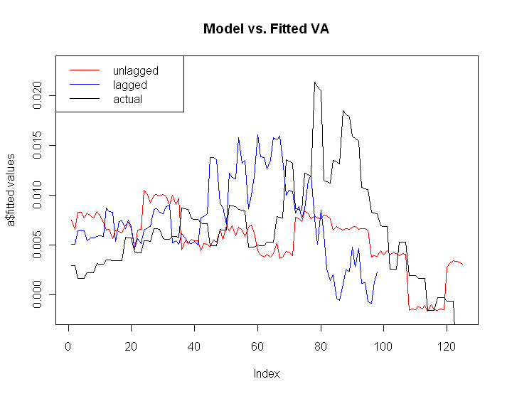
Lagged:
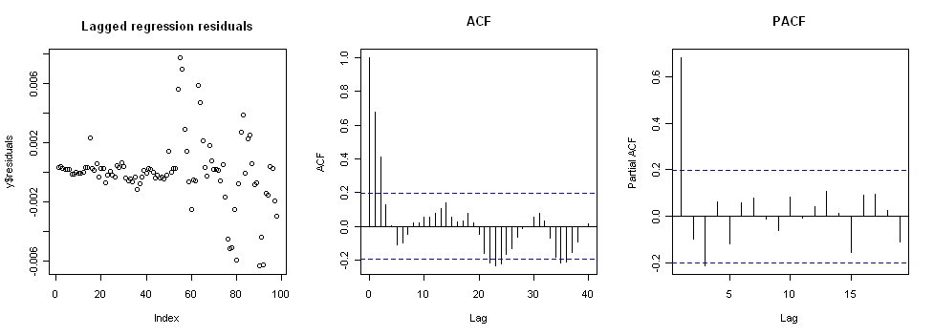

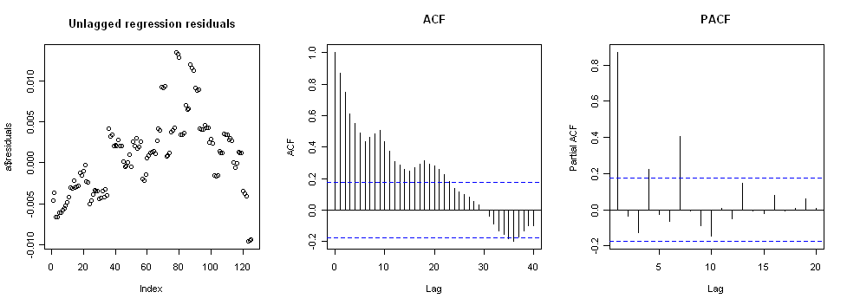

PACF shows k=4
Augmented Dickey-Fuller Test

data: y$residuals
Dickey-Fuller = -4.1054, Lag order = 4, p-value = 0.01
alternative hypothesis: stationary

Residuals are stationary so phase 1 complete. Continue to Phase 2.

First, check Box-Ljung.

Box-Ljung test

data: y$residuals
X-squared = 69.6419, df = 12, p-value = 3.737e-10
Box-Ljung fails. Implies residuals are autocorrelated. So we will now model the residuals as time series.

EACF shows that we should try to fit ARMA(0,2).

Fit ARMA:
Series: y$residuals
ARIMA(0,0,2) with zero mean

Call: auto.arima(x = y$residuals, stationary = T)

Coefficients:
ma1 ma2
0.7428 0.5067
s.e. 0.0869 0.0860

sigma^2 estimated as 2.598e-06: log likelihood = 490.69
AIC = -975.38 AICc = -975.13 BIC = -967.63
Check adequacy of ARMA
> Box.Ljung.test(arima.fit$residuals,lag = 12, adj.DF = 12-params)

Box-Ljung test

data: data
X-squared = 4.8118, df = 10, p-value = 0.9034

> Box.Ljung.test(arima.fit$residuals^2,lag = 12, adj.DF = 12)

Box-Ljung test

data: data
X-squared = 14.209, df = 12, p-value = 0.2876

Residuals^2 passes. GARCH modeling not needed.

